Website Purpose: To help the most disadvantaged groups in the urban community achieve financial self sufficiency through education, coaching and community partnerships referrals.

**BLOG WEBSITE:** **CALYX LIFE**

**A. KEY CHARACTERISTICS**

* Educational Videos to educate people in the urban communities through Personal Financial Education 101, through articles.
* Contact page for one on one consulting
* Weekly interview videos with community partners and experts in the field.
* Referrals through direct links to community partners

**B. TWO SIMILAR WEBSITES: Credit Karma & Discover**

**Similarities:**

Credit Karma is a free website that provides free credit scores to its users &

the credit scores are from Equifax and Transunion (Major Credit Bureaus)

Discover also provides credit scores for free & credit score used is Experian (Major Credit Bureau)

**Differences:**

Credit Karma provides a tool to efile your tax return for free whereas Discover does not & Credit Karma provides simulations to improve credit scores

Both websites include an education on how to improve your credit score and education on right financial products to use.

**C. WEBSITE purpose:**

* To share my story and journey to self sufficiency with proven techniques that worked for me
* To educate my gente (my people) on free self service tools to maximize financial resources
* The pledge that a percentage of ALL net transactions will be donated to charitable institutions that foster self sufficiency in the urban communities.
* To educate the people on topics that matters to them regarding personal financing 101

**D. WEBSITE GOALS:**

* To tackle real life financial barriers that prevent them from accessing resources
* To coach people on how to be your best self advocate
* To foster a sense of community and responsibility for the oppressed economically
* To share the knowledge acquired through CALYX LIFE to their friends and community
* To start a financial awakening to communities that were not born into wealth by teaching them how to build wealth

**E. MILESTONES**

* Adding a mailing list to keep the community of readers connected with the content/ website creator
* Adding a review/ comments/ suggestions box for people to express what topics matters to them
* Adding a pay button for purchases
* Adding a donate button as little as a $1 to help a random stranger at the end of the month, through a pooled community fund
* To create an encrypted messaging system so that clients can safely upload their sensitive information

**F. METRICS:**

1. Demographics such as income bracket
2. Types of income
3. Family or household composition

**Through a matrix that measures the above and tabulated through the intake process**

**G. Analytics:**

1. What type of income bracket do we serve the most so that we can tailor their supplemental resources (such as future sales and incentives to refer more people from that given demographic)
2. Analyzing forms of no traditional income e.g. cash on hand, self employment, crypto and tailor financial solutions based on their need.
3. By identifying the commonalities in income, income barriers and income goals, CALYX will be able to tailor the experiences based on the current needs.

**H. WEBSITE CONTENT**

**I. TEXT AND IMAGES TOOLS**

* **TEXT**
* **IMAGE**
  + Giphy Chrome - <https://chrome.google.com/webstore/detail/giphy-for-chrome/jlleokkdhkflpmghiioglgmnminbekdi?hl=en>
    - Giphy for Chrome is a GIF Generator
  + Emoji generator on Mac
    - To generate emojis

**J. MAIN PIECES OF TEXT TEMPLATES**

**K. 2 ACCESSIBILITY CONSIDERATIONS:**

* Site translated to Spanish from English
* Website Articles Audio Readers by Content Creator to cater to blind and hand mobility imapired consumers e.g. Parkinsons, Nerve damage, Arthritis

**L. WEBSITE CONTENT: FUNDAMENTALS**

**M. SITE MAP**

**N. LAYOUT CHOICE**

**O. TARGET AUDIENCE**

The oppressed financially, meaning the ones that get utility shutoffs, eviction notices, spend their money to feel good, “instant gratification”

**P. FONTS**

**Q. TYPOGRAPHY**

**R. FUNCTIONALITIES**

**S. COLORS**

Webfx random color ideas, gave me the idea of shades of purples

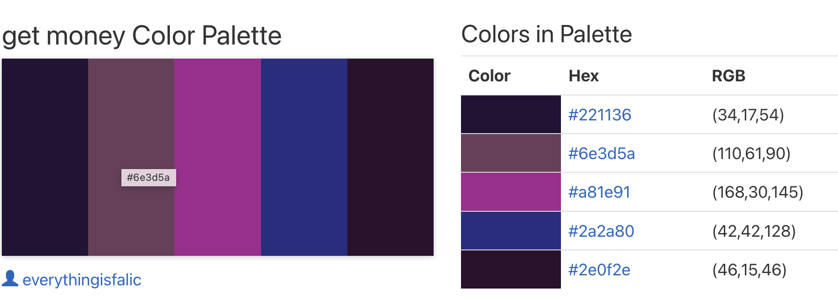

**T. Mockup: Work in Progress**

2 separate and different design pieces/pages of your mockup designed with a tool like Figma.